**EXPERIMENT # 8**

**Aim: Study and Perform Full wave rectification**

**Rectification** is the conversion of alternating current into direct current. In **full wave rectification**, both halves of alternating cycle is converted into unidirectional current.

# Apparatus

* Diodes
* Resistors
* Capacitors
* Function generator/ voltage source
* Oscilloscope

# Procedure

* We took resistor, diodes and capacitor and connected diodes like bridge type arrangement.

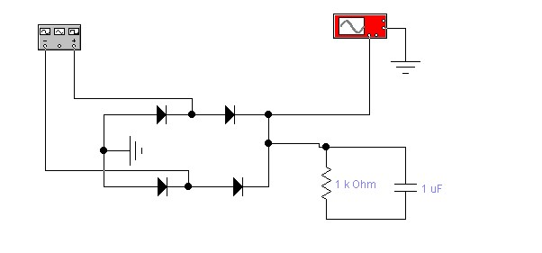

* Wave form is observed by connecting probe with oscilloscope and circuit. • Waveform obtained was observed.
* Experiment was performed for both positive and negative full wave’s rectification.

**Observations**

# Positive wave-form

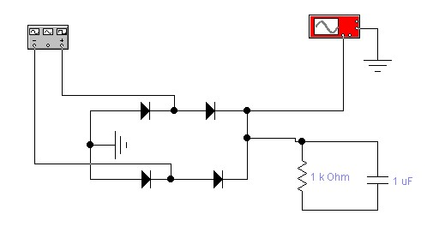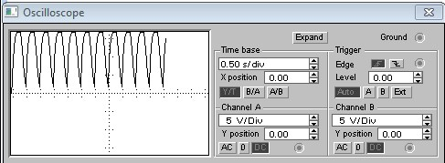

# Negative wave-form

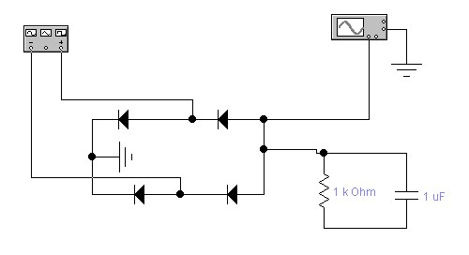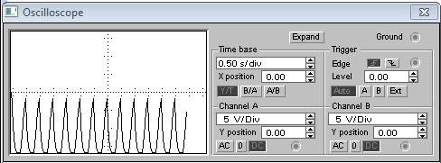

**Waveform with voltage source in circuit**

# Positive waveform

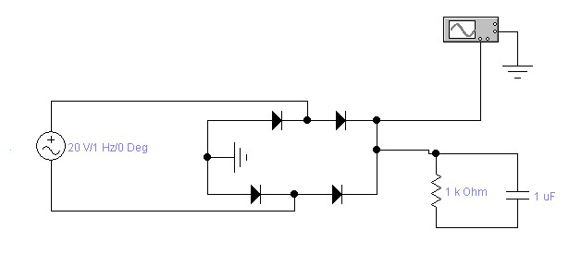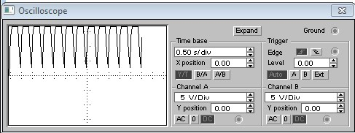

# Negative waveform

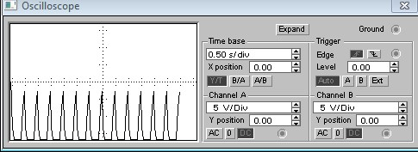

INSTRUCTOR VERIFICATION SHEET

For each verification, be prepared to explain your answer and respond to other related questions that the lab TA’s or Instructors might ask.

Name: Date of Lab:

Q. No. 01

Q. No. 02

## Q. No. 03

Verified: Date/Time: